Tab 1

Feature, Not a Bug — Inside India’s Currency Strategy
The narrative around the Indian Rupee is shifting. It is no longer just about market forces dragging the currency down; it is about a calculated adjustment to a changing global economic order. From central bank classifications to the travel plans of students, the depreciation of the Rupee is reshaping India's economic landscape.

1. A New Regime: The Managed Slide
The story begins with how the currency is defined. The era of a rigid defense of the Rupee appears to be over.
- IMF Classification: The International Monetary Fund has reclassified India’s exchange rate regime from a "stabilized arrangement" to a "crawl-like arrangement." This technical shift signifies that the RBI is allowing the currency to depreciate gradually within a controlled band rather than pinning it to a fixed rate.
- SBI’s Perspective: Corroborating this view, SBI Research uses a "Markov-Switching" model to identify the Rupee as currently being in "Regime 2" (Depreciating Regime). This statistical behavior points to a period of sustained weakness rather than stability.

2. The Global Race to the Bottom
Why allow the Rupee to fall? The answer lies in competitiveness. India is locked in a battle with other Emerging Markets to keep its exports attractive against a surging US Dollar.
- Brazil (BRL): Has seen massive depreciation (+179.99%), facing high volatility.
- India (INR): Is seeing a steady, controlled slide (+91.30% long-term trend).
- Thailand (THB): Is an outlier with appreciation (-8.45%), which effectively hurts its tourism and exports compared to India.
The Benefit: By allowing the Rupee to slide to levels like 91, India ensures that its exports remain cheaper and more attractive to global buyers than those of competitors with stronger currencies.

3. The Paradox of Reserves
A common misconception is that a falling currency implies a lack of ammunition to defend it. The data suggests otherwise. India possesses a massive "war chest," but the RBI’s strategy has changed.
- The Numbers: Forex reserves stood at ~$687 billion in December 2025, down slightly from a peak of ~$703 billion in June 2025.
- The Strategy: The RBI is not using these reserves to defend a specific psychological level, such as 85 or 90. Instead, it spent roughly $30 billion in 2025 purely to smooth out volatility—acting as a cushion—rather than attempting to reverse the trend. This preserves the bulk of reserves for genuine global emergencies.

4. Sectoral Impact: The IT Windfall and Hedging Costs
The depreciation creates a mixed picture for the services sector, which contributes ~55% to India's GVA.
- The Boon: IT giants like TCS and Infosys, which bill in USD but pay salaries in INR, see a direct boost in profit margins as the Rupee moves from ₹85 to ₹91.
- The Cost: However, volatility has a price. As speculators short the Rupee, the premiums to buy forward contracts (insurance against currency swings) rise. These increased hedging costs eat into some of the windfall profits.

5. The Investor’s Dilemma: FPIs and the "Return Gap"
While the stock market may hit record highs in Rupee terms, the currency slide creates a "return gap" that drives foreign money away.
- The Gap: A ~3% annual depreciation of the Rupee significantly reduces the actual return for a US-based investor.
- The Exodus: To avoid these currency losses, Foreign Portfolio Investors (FPIs) triggered a ₹17,242 crore outflow in December 2025, moving capital back to strengthening US Dollar assets.

6. The Personal Cost: Travel and Education
For the Indian citizen, the macroeconomic strategy translates into immediate financial pressure.
- Travel: With tour costs rising by 8–12%, travelers are abandoning "long-haul" trips to Europe or the USA. Instead, they are pivoting to "short-haul" budget destinations like Vietnam, Azerbaijan, and Dubai.
- Education: For students studying abroad, a 6% currency drop is effectively an overnight 6% tuition fee hike, forcing families to increase their education loan amounts to cover the gap.

7. What Lies Ahead? (SBI Report Predictions)
How long will this last? The SBI research report offers a specific timeline and target.
- Duration: The "Depreciating Regime" is expected to persist for approximately 6.3 months.
- Targets: The Rupee could slide further to ₹92–92.5.
- Recovery: The model predicts a "mean reversion" (bounce back) to ~₹87 in late 2026.

Conclusion: Strategic Necessity
The prevailing economic consensus is that the current depreciation is "a feature, not a bug." In a world characterized by high tariffs and slowing trade, a weaker Rupee acts as a necessary shock absorber.
- It naturally discourages imports, helping manage the trade deficit.
- It boosts goods exports, which were up 19.4% in November 2025.
- It protects sovereign reserves from being wasted on defending arbitrary exchange rates.
Ultimately, the policy prioritizes long-term export competitiveness over the short-term convenience of cheap foreign travel or foreign capital inflows.

Disclaimer: The content should not be construed as investment, trading, or personal financial advice.This blog is for educational purposes only.

Chart
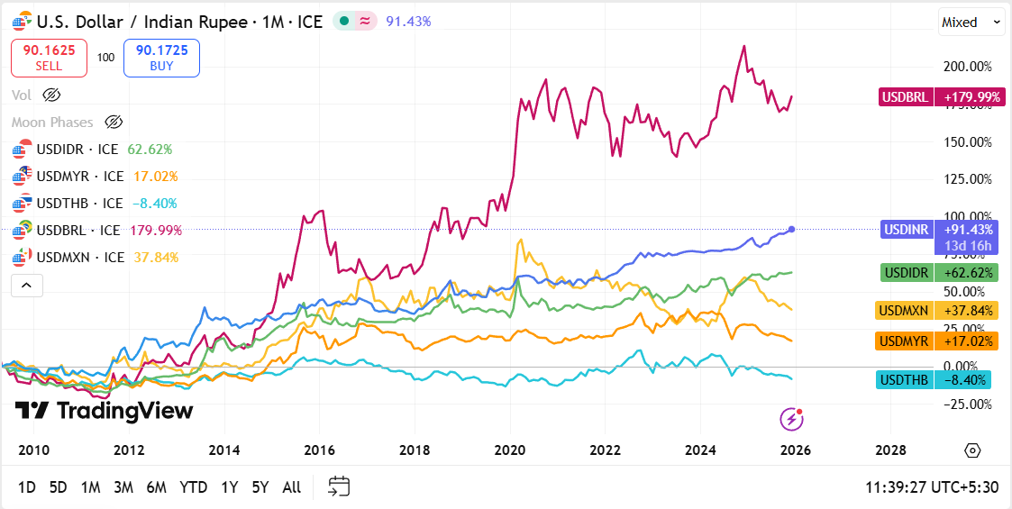

The

